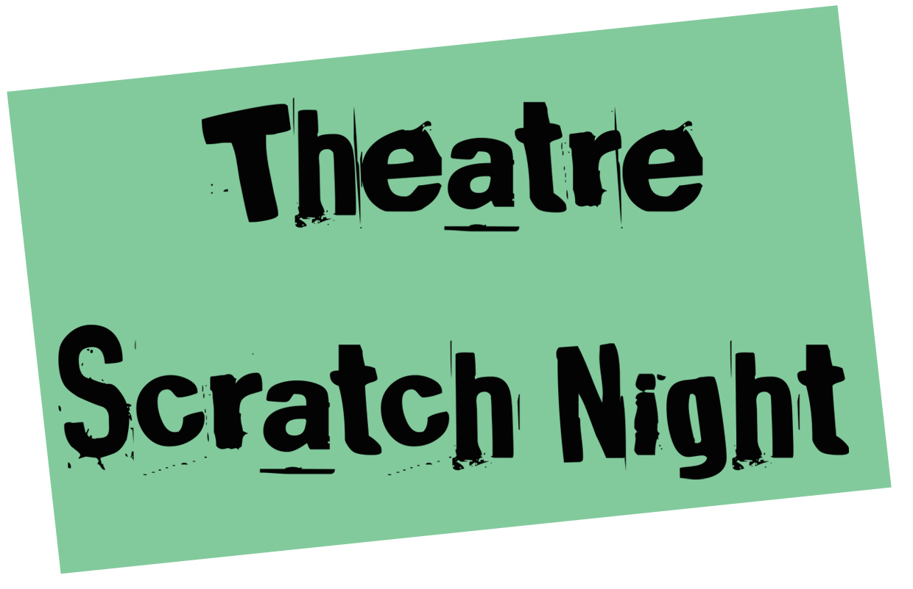

At The Old Fire Station | Curated by UnderConstruction Theatre

PERFORMER APPLICATION FORM

Company / Artist’s Name/s:

Main Contact Person:

Main Contact Number:

Main Contact E-mail:

Month of the Scratch night you wish to perform in:

If we are oversubscribed, are there any other months you would consider performing?

What is the title of the piece you wish to present?

Who has it been written by?

How many performers will be in it?

What are their names?

**Please note that we do not provide performers for your piece. In the future we would like to build up a network of performers who might be willing to perform pieces at Scratch nights, but at present if you are seeking performers we advise advertising through the Oxford Actors Network. “We have 70 odd (very) actors of all shapes, sizes, colours and sexes. And we're pretty much all housetrained.” Founding member, Steve Hay.

Can you give us a bit of background info about your work / career in the theatre so that we can put it in to context for the audience:

How long does the piece you are going to perform last? (Please note the maximum slot is 15 minutes)

A Sentence or Two about the idea you wish to scratch. i.e. what is the context? Has it been performed before? What do you want to get out of performing it at the scratch night?:

Would you describe it as a:

Work in Progress / Idea being presented / Piece of Script / Improvisation / Other – Please Describe.

Anything in particular you’d like feedback about from the audience on the night? Please formulate 2-3 specific questions that we can present.

Please provide up to 200 words MAXIMUM of information on the piece to go in the programme if your piece is selected:

Any technical / staging requirements that are necessary to your piece:

Do you need any furniture on the stage?

Will you be bringing any electrical equipment to use? (Please note all electrical equipment must have been PACT tested).

**Please note that we cannot guarantee your technical and stage requirements as these are dependent on all the pieces that are being shown that night, but will work with you to help try and give you what you need.

As there will be up to 3 pieces shown at each scratch, it is advisable to have as little set and prop requirements as necessary, to enable a quick changeover between pieces. You will only be able to deliver your set and props to the theatre up to a maximum of 1.5 hours before the scratch night commences, as notified when you receive a call time.

Please provide us with any links to your previous relevant work if you have them and / or send a short script extract if you would like in advance, complete with technical instructions.

Thank you. Once we have considered your piece, we will contact you to let you know if you have been selected for the scratch night you have identified, and what the arrangements are for a tech. We aim to select pieces at least two weeks before that scratch night itself and will have a max of three pieces per night!

Please return this form to lizzy@underconstructiontheatre.com with SCRATCH in the subject line.

Keep up to date with Scratch Night developments and news on Facebook and Twitter

www.facebook.com/TheatreScratchNight
@OFSScratchNight

Or sign up to our mailing list for updates at http://eepurl.com/onux1

